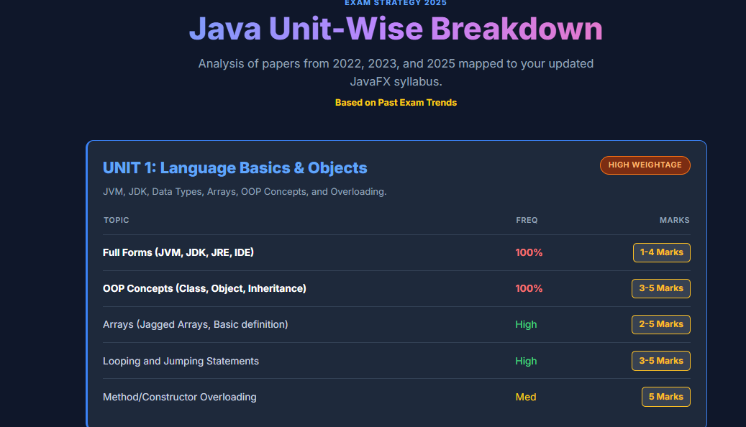
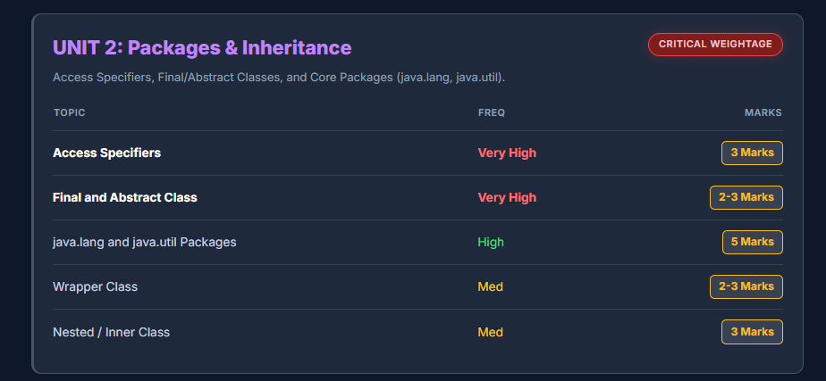
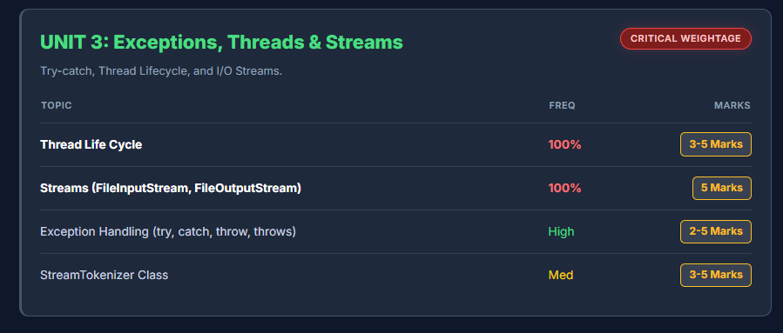
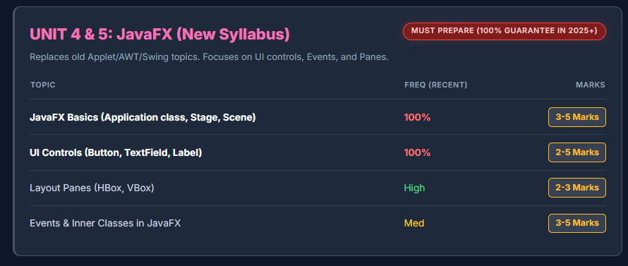
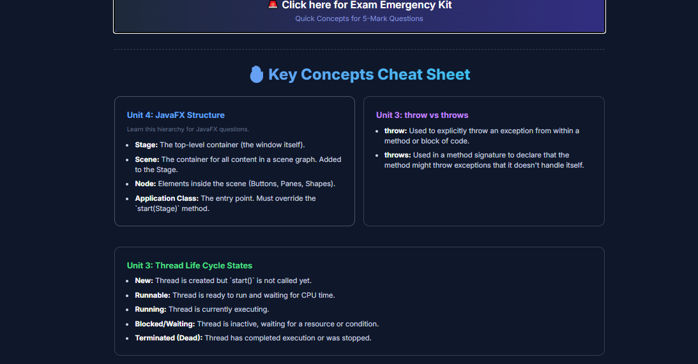

🧠 1. NEW EXAM PATTERN (VERY IMPORTANT)
From your new pattern image:
📊 Structure (Same for all Units)
Section | Marks | Type
(a) | 3 | Objective / Fill / small
(b) | 2 | Short answer
(c) | 5 | Long answer / Program
👉 Each unit = 10 marks
👉 Total = 50 marks

🔥 Key Change from Old Papers
Old papers → mixed questions
New pattern → UNIT-WISE
👉 Means:
- Unit 1 → basics
- Unit 2 → OOP
- Unit 3 → Threads + Exception
- Unit 4 → GUI
- Unit 5 → JavaFX
📌 So now EVERY UNIT is compulsory (no skipping!)

🔁 2. Recurring Topics (From All Papers)
After comparing:
- (2022)
- (2025)
- (2023)
👉 These topics appear again and again:
🔥 HIGH FREQUENCY
- JVM / JDK / JRE
- Tokens
- Looping / Jumping
- OOP concepts
- Inheritance / Overriding
- Exception Handling
- Thread
- File Handling
- AWT / Swing
- JavaFX

🧩 3. Concept Clusters (Examiner Strategy)
Examiner never asks random questions.
They follow this:
Unit-wise Clusters:
Unit | Cluster
Unit 1 | Basics (JVM, Tokens, Loops)
Unit 2 | OOP + Packages
Unit 3 | Exception + Thread + File
Unit 4 | AWT + Swing
Unit 5 | JavaFX
👉 This pattern is clearly visible in 2022 + 2025 papers.

🏆 4. TOP 10 MOST PROBABLE TOPICS (FINAL LIST)
⭐ 1. JVM / JRE / JDK
📌 Asked in ALL papers
📌 Easy MCQ + short

⭐ 2. Java Tokens
📌 Asked in 2025
📌 Comes as 5-mark theory

⭐ 3. Looping + Jumping
📌 Appears in Unit 1 always
📌 Program-based question

⭐ 4. OOP Concepts
📌 Asked in 2023 + 2025
📌 Long answer

⭐ 5. Inheritance + Overriding
📌 Repeated in 2022 + 2023
📌 Program + theory

⭐ 6. Access Specifiers + Packages
📌 Seen in 2025
📌 Short + long mix

⭐ 7. Exception Handling
📌 ALWAYS present
📌 try-catch / throw

⭐ 8. Thread (VERY IMPORTANT)
📌 Thread lifecycle + synchronization
📌 Program question appears

⭐ 9. File Handling (Streams)
📌 FileInputStream, OutputStream
📌 StreamTokenizer repeated

⭐ 10. GUI (AWT / Swing / JavaFX)
📌 Very heavy weight
📌 Unit 4 + Unit 5

🎯 5. MOST EXPECTED QUESTIONS (NEXT EXAM)
Based on trend:
Unit 1
- Full forms (JVM, JDK)
- Tokens
- Looping

Unit 2
- OOP concepts
- Inheritance
- Access specifiers

Unit 3
- Exception handling
- Thread lifecycle
- FileInputStream

Unit 4
- AWT vs Swing
- Layout manager
- Event delegation

Unit 5
- JavaFX basics
- Panes
- Button / TextField

🧠 6. BIG PROBLEM: “I can’t remember everything”
👉 This is NORMAL.
👉 Solution = smart memory system (not hard study)

🚀 7. SMART STUDY METHOD (GAME CHANGER)
🔹 Method 1: “3-POINT RULE”
For EVERY answer:
- Definition
- 2–3 key points
- 1 example
👉 Enough to get full marks

🔹 Method 3: “Repeat, Don’t Read”
Wrong ❌ → Reading again and again
Correct ✅ → Write + revise

🔹 Method 4: “Memory Hack”
Convert to simple meaning:
- JVM → “runs program”
- Thread → “multi work”
- Exception → “error handling”
👉 Brain remembers meaning, not text

🔹 Method 5: “Exam Writing Trick”
Write like this:
Definition
+
2 points
+
Example
+
Conclusion (optional)
👉 Even if small answer → looks BIG

⚡ FINAL STRATEGY (MOST IMPORTANT)
👉 You DON’T need full syllabus
👉 You need:
- Top 10 topics ✅
- Unit-wise revision ✅
- Writing practice ✅

Great — now I’ll give you FINAL MOST IMPORTANT QUESTIONS for 2026 exam based on:
- 2022 paper
- 2023 paper
- 2025 paper
- New unit-wise pattern (2024)
👉 This is smart predicted question list (high accuracy)

🔥 FINAL IMPORTANT QUESTIONS (UNIT-WISE)

📘 UNIT 1 (Basics)
⭐ MUST STUDY
- Full form of:
  - JVM
  - JRE
  - JDK
- What is Java Tokens? Explain types
- What is Java IDE?
- What is Array?
- What is Enum?
- What is JAVAC?

⭐ VERY IMPORTANT (5 MARK)
- Explain Looping statements in Java
- Explain Jumping statements (break, continue)

🎯 HIGH CHANCE PROGRAM
- Write program for:
  - Sum of 1 to N
  - Prime number
  - Factorial

📘 UNIT 2 (OOP + Packages)
⭐ MUST STUDY
- Full form of:
  - API
  - OOP
  - AWT
- What is Access Specifier? Explain types
- What is Package?
- What is User-defined package?

⭐ VERY IMPORTANT
- Explain OOP concepts:
  - Class
  - Object
  - Encapsulation
  - Polymorphism

🎯 HIGH CHANCE (5 MARK)
- Explain Inheritance with types
- Explain Method Overriding with example
- Explain java.util package
- Explain java.lang package

📘 UNIT 3 (Exception + Thread + File)
⭐ MUST STUDY
- What is Exception?
- What is try-catch?
- What is throw keyword?
- What is EOF?

⭐ VERY IMPORTANT
- What is Thread?
- Explain Thread Life Cycle
- What is Synchronization?

🎯 HIGH CHANCE (5 MARK)
- Explain FileInputStream & FileOutputStream
- Explain StreamTokenizer Class

🎯 PROGRAM (VERY IMPORTANT)
- Program:
- Even & Odd using threads
- File read/write

📘 UNIT 4 (AWT + Swing)
⭐ MUST STUDY
- What is AWT?
- What is Swing?
- Difference between AWT and Swing

⭐ VERY IMPORTANT
- What is Layout Manager? Types
- What is Event Delegation Model
- What is Adapter Class

🎯 HIGH CHANCE (5 MARK)
- Explain Applet Life Cycle
- Explain GridBagLayout

🎯 PROGRAM
- Calculator using Swing
- Menu program using Swing

📘 UNIT 5 (JavaFX)
⭐ MUST STUDY
- What is JavaFX?
- Full form of JavaFX
- What is Stage and Scene?

⭐ VERY IMPORTANT
- What is Pane?
- What is Label?
- What is TextField?
- What is Button?

🎯 HIGH CHANCE (5 MARK)
- Explain Property Binding
- Explain JavaFX controls

🎯 VERY IMPORTANT (NEW PATTERN)
- Layouts:
- HBox (horizontal)
- VBox (vertical)

🧠 FINAL SHORTLIST (TOP 15 ONLY)
👉 If time is less, ONLY do this:
- JVM / JDK / JRE
- Tokens
- Loops
- OOP concepts
- Inheritance
- Access Specifiers
- Exception
- Thread lifecycle
- FileInputStream
- AWT vs Swing
- Event Delegation
- Layout Manager
- JavaFX basics
- Pane + Button
- Property Binding

🚀 HOW TO PREPARE (LAST 3 DAYS PLAN)
Day 1
- Unit 1 + Unit 2
Day 2
- Unit 3
Day 3
- Unit 4 + Unit 5

⚡ GOLDEN EXAM HACK
👉 Write answers like:
- Definition
- 3 points
- Example
👉 Even small answer → gets full marks

🔥 REAL TRUTH
👉 Paper is NOT difficult
👉 Pattern is predictable
👉 You just need right topics

